Southeastern Cooperative Wildlife Disease Study
College of Veterinary Medicine
University of Georgia
Athens, Georgia 30602
Phone: 706-542-1741

December 7, 2017

TO: Dr. Angela M. James
Center for Epidemiology and Animal Health
USDA, APHIS, Veterinary Services
2150 Centre Ave., Building B
Fort Collins, Colorado, 80526

FROM: Dr. Joseph L. Corn, Dr. Michael J. Yabsley, and Ms. Madeleine A. Pfaff
Southeastern Cooperative Wildlife Disease Study
College of Veterinary Medicine
University of Georgia
Athens, Georgia 30602

SUBJECT: Final Report for Cooperative Agreement No. 15-9200-0444-CA between the Southeastern Cooperative Wildlife Disease Study (SCWDS), College of Veterinary Medicine, University of Georgia, and the Center for Epidemiology and Animal Health (CEAH), Veterinary Services (VS), Animal and Plant Health Inspection Service (APHIS), United States Department of Agriculture (USDA)

COOPERATIVE AGREEMENT PERIOD:

September 17, 2015 – September 16, 2016
No-cost Extension to 9/15/2017

TITLE: Tick Phenology

OVERVIEW

The purpose of this Cooperative Agreement is for SCWDS to create datasets for use in the development of APHIS’s predictive tick species distribution models. Goals for this Cooperative Agreement are to (1) collect ticks from different habitat types in the Mountain (North Carolina), Piedmont (Georgia), Upper Coastal Plain (Georgia and South Carolina), and Lower Coastal Plain (South Carolina) physiographic regions of the Southeastern United States, and (2) identify tick species and associated tick-borne disease pathogens collected in these regions.

Funding for this Cooperative Agreement began September 2015, but field work was not scheduled to begin until July 2016. Field work is being conducted July 2016 – May 2017. Identification of ticks and associated tick-borne pathogens, and preparation of reports is in progress and scheduled to continue through May 2018. One M.S. level graduate student (Madeleine Pfaff) began work June 1, 2016, and is expected to complete her program in May 2018. This Cooperative Agreement was awarded a No-Cost Extension.

ACCOMPLISHMENTS

PROJECT DESIGN

Project design, including site selection, sampling schedule, and data collected are outlined below:

Site Selection

Regions, study sites and habitats sampled are as follows:

Four physiographic regions:
- Mountain
Habitats: Mesic Mixed Hardwood Forest, Montane Conifer-dominated Forest, Rhododendron-dominated Montane Riparian
  - Pisgah National Forest, NC
- Piedmont
Habitats: Bottomland Hardwood Forest, Upland Hardwood, Loblolly Pine Forest
  - Oconee National Forest, GA
- Upper Coastal Plain
Habitats: Successional Fields, Pine uplands, Bottomland Hardwood Forest
  - DiLane WMA, GA
  - Savannah River Site, SC
- Lower Coastal Plain
Habitats: Maritime Forest, Longleaf Pine Forest, Bottomland Hardwood Forest
  - Francis Marion National Forest, SC
  - Tom Yawkey Wildlife Center, SC

Within each physiographic region, three habitat types were selected. Three sites of each habitat type were selected per region.

Total habitat types sampled: 12
Total plots surveyed: 36
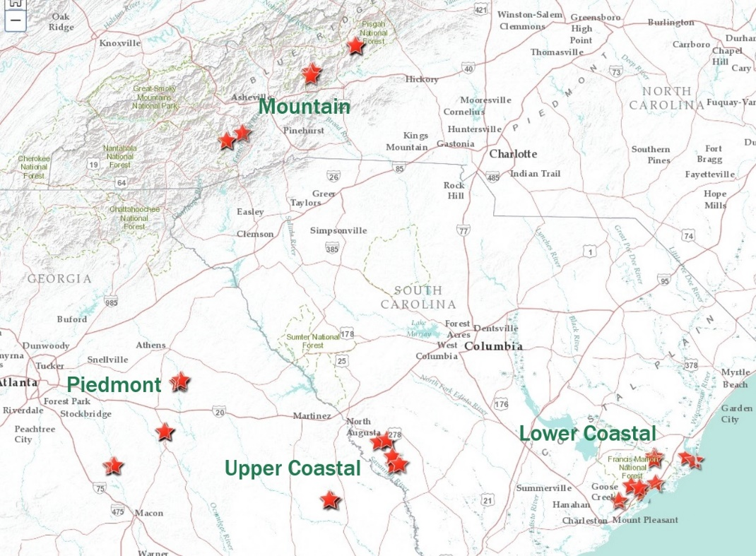

Figure 1. Locations of the 36 sites in the four physiographic regions included in our study.

Quarterly Sampling Schedule

Summer: July/August 2016
Fall: October/November 2016
Winter: January/February 2017
Spring: April/May 2017

Tick Collection and testing

Tick sampling was conducted at quarterly intervals, with each plot being sampled once per quarter. This allows for evaluation of the phenology of various tick species.

Tick sampling was conducted after 10:00 AM, or later if necessary, when vegetation was dry and temperatures were >0 C. No sampling was conducted on days with inclement weather (heavy rain, snow, excessive wind). Adult, nymph and larval ticks were preserved in 70% ethanol.

At each site, we established twenty transects, 25 meters in length. Tick drags were completed along these transects for a total of 500 m of dragging per site.
Ticks were identified to species, life stage and sex using published dichotomous keys. DNA was extracted from ticks using Qiagen DNeasy Blood and Tissue kits and a subset of ticks were tested for pathogens of interest using various PCR assays. Rickettsia spp. A subset of A. americanum, A. maculatum, and D. variabilis nymph and adult ticks were screened for Rickettsia spp. by a nested PCR targeting the 17kDa gene (Gleim et al. 2016). Samples positive for Rickettsia spp. were purified and submitted to Georgia Genomics Facility for sequencing to determine species of Rickettsia. A subset of A. americanum ticks was screened for Ehrlichia chaffeensis using a nested PCR targeting the 16S gene (Anderson et al. 1992a). A subset of A. americanum ticks were screened for Ehrlichia ewingii using a nested PCR targeting the 16S gene (Dawson et al. 1996). All Ixodes scapularis and Ixodes affinis ticks were screened for Anaplasma phagocytophilum using a nested PCR targeting the 16S gene (Little et al. 1997).

In the original agreement, Ixodes scapularis were to be tested for B. burgdorferi by the Centers for Disease Control. However, testing has not been conducted so we are currently testing all Ixodes spp. for Borrelia spp. using a nested PCR targeting the flagellin (flaB) gene (Barbour et al. 1996, Gleim et al. 2016). Borrelia testing is underway and will be complete by early January 2018.

Environmental Data Collection

Tree Density
Within each area of habitat surveyed, we randomly choose 10 points. A quarter-point survey was used to quantify tree density. The closest small (2.5-40 cm DBH) and closest large (>40cm DBH) trees were recorded in each quadrant (<10 m from center point). Each point served as the point of reference for all other habitat measurements.

Canopy closure
Canopy closure was measured from the center point of the previously established plots using a spherical densiometer. The closest tree >2.5 cm in diameter was used as the reference tree. From the reference tree, the person using the instrument stood just outside the extent of the crown to take readings in each of the four cardinal directions from the reference tree.

Ground cover composition
At the site of canopy closure measurements, understory vegetation was measured. To quantify understory vegetation characteristics, a 1x1m frame was placed with the sides of the frame running north to south and east to west. Within the frame, the percent cover of herbaceous vegetation, leaf litter, rock, and bare soil were estimated. Photos of each site were also taken which will be used to better quantify species present.

Litter depth
Litter depth was measured at each of the 10 understory vegetation points.

Microclimatic measurements
Three microclimate measurements (temperature, relative humidity and median wind speed) were taken at the start point of the first and last transect of each plot.

Weather data
Weather data including maximum temperature and precipitation the current sampling day, maximum and minimum temperatures the previous day, and precipitation accumulation the previous 3 days were collected for all plots using data from the National Weather Service.

RESULTS

Site Selection

SCWDS identified potential study sites in the Mountain (North Carolina), Piedmont (Georgia), Upper Coastal Plain (Georgia and South Carolina), and Lower Coastal Plain (South Carolina). Permits were acquired from wildlife resources and land management agencies. Sites in all four regions were visited, three habitat types were identified in each region, and replicate study sites selected in each habitat type. Tick collections began in July 2016.

Environmental Data Collection

These data were provided to Dr. James in summary and individual data in excel documents.

Tick Collections and Tick Identification

Ticks were collected at three of our four regions; no ticks were collected at any Mountain region (Table 1). Ticks were collected during all four sampling periods; 381 ticks were collected in Summer 2016, 197 were collected in Fall 2016, 558 were collected in Winter 2017, and 832 were collected in Spring 2017. Each cluster of larval ticks is counted as one tick. All three life stages of ticks were collected from drag and flag cloths. Five species of ticks were collected during the four sampling sessions including Amblyomma americanum, Amblyomma maculatum, Dermacentor variabilis, Ixodes scapularis and Ixodes affinis (Figure 1).

Table 1. Total ticks collected from each region and site
Season | Region | Habitat | # of ticks | # of each tick species
Summer | Lower Coastal | Bottomland Hardwood | 40 | Amblyomma americanum
Summer | Lower Coastal | Bottomland Hardwood | 3 | Ixodes affinis
Summer | Lower Coastal | Bottomland Hardwood | 2 | Larval clusters (A. americanum)
Summer | Lower Coastal | Longleaf Pine | 8 | Amblyomma americanum
Summer | Lower Coastal | Longleaf Pine | 1 | Larval clusters (A. americanum)
Summer | Lower Coastal | Maritime Forest | 18 | Amblyomma americanum
Summer | Lower Coastal | Maritime Forest | 2 | Ixodes affinis
Summer | Piedmont | Bottomland hardwood | 45 | Amblyomma americanum
Summer | Piedmont | Bottomland hardwood | 2 | Dermacentor variabilis
Summer | Piedmont | Bottomland hardwood | 4 | Larval clusters (A. americanum)
Summer | Piedmont | Upland mixed hardwood | 182 | Amblyomma americanum
Summer | Piedmont | Upland mixed hardwood | 3 | Larval clusters (A. americanum)
Summer | Piedmont | Upland mixed hardwood | 1 | Dermacentor variabilis
Summer | Piedmont | Pine | 54 | Amblyomma americanum
Summer | Piedmont | Pine | 4 | Larval clusters (A. americanum)
Summer | Piedmont | Pine | 1 | Dermacentor variabilis
Summer | Upper Coastal | Early successional field | 1 | Amblyomma maculatum
Summer | Upper Coastal | Pine | 1 | Larval clusters (A. americanum)
Summer | Upper Coastal | Pine | 1 | Amblyomma americanum
Summer | Upper Coastal | Pine | 1 | Amblyomma maculatum
Summer | Upper Coastal | Bottomland hardwood | 3 | Amblyomma americanum
Summer | Upper Coastal | Bottomland hardwood | 2 | Larval clusters (A. americanum)
Summer | Upper Coastal | Bottomland hardwood | 1 | Ixodes scapularis
Summer | Upper Coastal | Bottomland hardwood | 1 | Dermacentor variabilis
Fall | Lower Coastal | Bottomland hardwood | 46 | Ixodes scapularis
Fall | Lower Coastal | Bottomland hardwood | 7 | Amblyomma americanum
Fall | Lower Coastal | Bottomland hardwood | 5 | Larval clusters (A. americanum)
Fall | Lower Coastal | Bottomland hardwood | 2 | Ixodes affinis
Fall | Lower Coastal | Longleaf pine | 1 | Ixodes scapularis
Fall | Lower Coastal | Longleaf pine | 1 | Amblyomma americanum
Fall | Lower Coastal | Maritime forest | 13 | Ixodes scapularis
Fall | Lower Coastal | Maritime forest | 3 | Ixodes affinis
Fall | Lower Coastal | Maritime forest | 2 | Amblyomma americanum
Fall | Piedmont | Bottomland hardwood | 13 | Ixodes scapularis
Fall | Piedmont | Bottomland hardwood | 4 | Larval clusters (A. americanum)
Fall | Piedmont | Upland mixed hardwood | 20 | Ixodes scapularis
Fall | Piedmont | Upland mixed hardwood | 7 | Larval clusters (A. americanum)
Fall | Piedmont | Pine | 25 | Ixodes scapularis
Fall | Piedmont | Pine | 5 | Amblyomma americanum
Fall | Piedmont | Pine | 4 | Larval clusters (A. americanum)
Fall | Upper coastal | Early successional field | 0
Fall | Upper coastal | Pine | 0
Fall | Upper coastal | Bottomland hardwood | 37 | Ixodes scapularis
Fall | Upper coastal | Bottomland hardwood | 2 | Amblyomma americanum
Winter | Lower coastal | Bottomland hardwood | 2 | Amblyomma americanum
Winter | Lower coastal | Bottomland hardwood | 41 | Ixodes scapularis
Winter | Lower coastal | Bottomland hardwood | 1 | Ixodes affinis
Winter | Lower coastal | Longleaf pine | 0
Winter | Lower coastal | Maritime forest | 1 | Amblyomma americanum
Winter | Lower coastal | Maritime forest | 23 | Ixodes scapularis
Winter | Lower coastal | Maritime forest | 3 | Ixodes affinis
Winter | Piedmont | Bottomland hardwood | 50 | Ixodes scapularis
Winter | Piedmont | Bottomland hardwood | 20 | Amblyomma americanum
Winter | Piedmont | Upland mixed hardwood | 63 | Ixodes scapularis
Winter | Piedmont | Upland mixed hardwood | 271 | Amblyomma americanum
Winter | Piedmont | Pine | 26 | Ixodes scapularis
Winter | Piedmont | Pine | 19 | Amblyomma americanum
Winter | Upper coastal | Early successional field | 0
Winter | Upper coastal | Pine | 2 | Ixodes scapularis
Winter | Upper coastal | Bottomland hardwood | 2 | Amblyomma americanum
Winter | Upper coastal | Bottomland hardwood | 34 | Ixodes scapularis
Spring | Lower coastal | Bottomland hardwood | 284 | Amblyomma americanum
Spring | Lower coastal |  | 2 | Ixodes affinis
Spring | Lower coastal |  | 2 | Ixodes scapularis
Spring | Lower coastal |  | 2 | Dermacentor variabilis
Spring | Lower coastal | Longleaf pine | 3 | Amblyomma americanum
Spring | Lower coastal | Maritime forest | 3 | Ixodes scapularis
Spring | Lower coastal |  | 79 | Amblyomma americanum
Spring | Piedmont | Bottomland hardwood | 1 | Dermacentor variabilis
Spring | Piedmont |  | 8 | Ixodes scapularis
Spring | Piedmont |  | 219 | Amblyomma americanum
Spring | Piedmont | Upland mixed hardwood | 2 | Ixodes scapularis
Spring | Piedmont |  | 129 | Amblyomma americanum
Spring | Piedmont | Pine | 66 | Amblyomma americanum
Spring | Piedmont |  | 1 | Ixodes scapularis
Spring | Upper Coastal | Early successional field | 0
Spring | Upper Coastal | Pine | 0
Spring | Upper Coastal | Bottomland hardwood | 1 | Dermacentor variabilis
Spring | Upper Coastal | Bottomland hardwood | 3 | Ixodes scapularis
Spring | Upper Coastal | Bottomland hardwood | 27 | Amblyomma americanum

Figure 1. Phenology of ticks collected during the four seasons sampled.

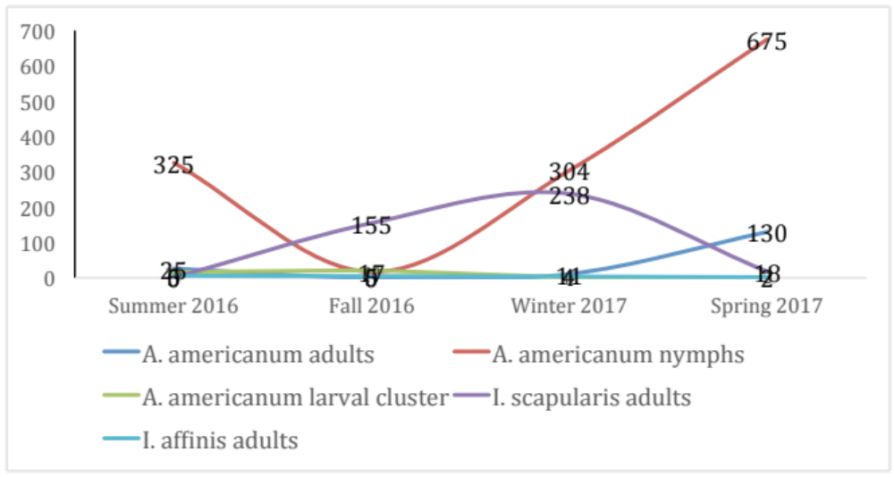

Pathogen Screening

A summary of our findings is shown in Table 3. Detailed pathogen testing per individual tick was provided to Dr. James as an excel document.

1. Amblyomma americanum
Rickettsia spp. – A total of 398 of 530 (75%) ticks were positive. Sequence analysis of a subset indicated that all were infected with R. amblyommatis.
Ehrlichia spp. -- Of 593 tick tested, 5 and 4 were positive for E. chaffeensis and E. ewingii, respectively.

2. Amblyomma maculatum
Both A. maculatum detected were positive for Rickettsia. Based on sequence analysis, one was infected with R. parkeri while the other is an unknown Rickettsia sp. due to sequence failure.

3. Dermacentor variablis
Rickettsia spp. – All 9 ticks (100%) were positive.

4. Ixodes scapularis
Anaplasma phagocytophilum – 36 of 414 were PCR positive. A subset of these were sequenced and confirmed to be A. phagocytophilum.
Borrelia spp. – testing is underway.

5. Ixodes affinis
Anaplasma phagocytophilum – 1 of 16 were PCR positive.
Borrelia spp. – testing is underway.

Table 3. Results of pathogen testing
Species of Tick Tested | Pathogen | Number tested | % Positive
A. americanum | Rickettsia spp. | 530 | 72%
D. variabilis | Rickettsia spp. | 9 | 100%
A. maculatum | Rickettsia spp. | 2 | 100%
Ixodes spp. | A. phagocytophilum | 408 | 9%
A. americanum | E. ewingii | 593 | 0.7%
A. americanum | E. chaffeensis | 593 | 0.8%

Notes

Two Lower Coastal field sites at Tom Yawkey Nature Center were adversely affected by Hurricane Matthew in October 2016 just before the fall sampling period. Because Tom Yawkey is located on an island, access to the island was limited and sites were compromised by salt water surges and flooding. Two new sites (one longleaf pine forest and one maritime forest) were selected in nearby Francis Marion National Forest and surveyed for ticks and vegetation for the fall, winter and spring sampling periods.

Model Analysis

Work is currently underway to build models and analyze the collected data for use by USDA-APHIS.

